Quality Control of X-Ray
Student’s Name
Institution Affiliation
Course Number and Name
Instructor Name
Date

Quality Control of X-Ray
Introduction
Several operational sectors use different quality control programs that are aimed at enhancing the performance of the systems involved. The process can also be used in businesses and organizations in ensuring that the quality of products or services is maintained at some level of standard, defined by quality. Quality control (QC) necessitates the creation of an atmosphere where the employees or workers aim at perfection. Additionally, healthcare facilities and organizations optimize some set of quality control guidelines and programs that ensure the patient and healthcare providers are safe (Mitra, 2016). These programs increase the level of trust between the workers and the service receivers, who are the patients. High levels of QC often characterize the laboratories in the healthcare department. These include the laboratory QC that ensures the threats of non-conforming results are eliminated. With these set of programs, elements including timeliness, reliability, and accuracy are achieved in the outcomes of the machine and equipment setups.
The emergence of technology has adversely changed the operation and management of the radiographic equipment. The Xray is one of the dominant equipment used in radiography practice. Digital fluoroscopy and radiography have increased the complexities in Xray. For instance, the American Association of Physicists in Medicine (AAPM) has been publishing some value declaration procedure that guides some of the necessary directions to the radiologic engineer involved in an Xray test. This engineer is the primary individual that gets associated with the quality assurance (QA) system in analytical radiology. AAPM had previously assigned the supervision and development of a quantitative QA program role to the medical physicist who performs Xray imaging. Besides the AAPM, the WHO describes QA systems within diagnostic radiology as a combined effort by the Xray staff to certify that Xray images produced provide sufficient diagnostic information (Delis et al., 2017). Therefore, the quality of the image is the most significant concern in Xray QC. In this essay, different aspects of QC in the Xray machine are considered.
Discussion
QC in Xray mainly focuses on the Xray equipment that amalgamates both the quality and techniques management procedures. The complete and substantial amalgamation of these two elements enhances the maintenance and monitoring of the technical essentials constituted in the Xray system. As said, above, the main goal of the QC in Xray is the enhancement of the Xray images (Inkoom, 2011). Therefore, the components of the Xray system have to be understood in a broader and deeper context. The system constitutes of ana assembly of parts that control the construction of diagnostic pictures.
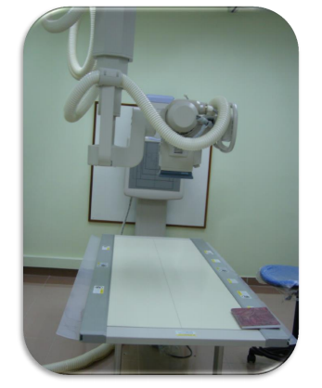
Some of the necessary inclusions for the QC procedure consists of commissioning and acceptance test, constancy tests, status tests, authentication QC equipment & material and radiation protection (RP), and finally necessary follow-ups. The trials of quality control have to be recorded in logs with correct dates and the right results for future references. This information is recorded and handled by the quality assurance department. The following diagram represents the simple illustration of the QC of an Xray machine;
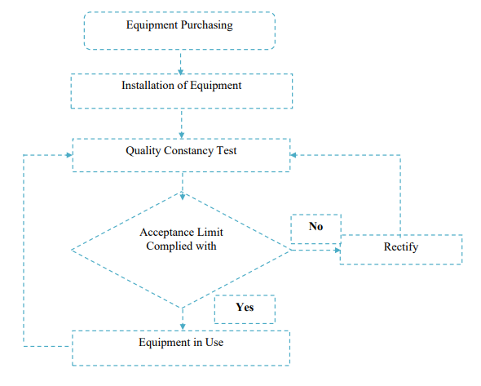
(AL-Jasim et al., 2017).
Choice of The Equipment
The selection of imaging equipment is an essential process in the QC process. The medical physicist assesses the appropriateness of the imaging equipment. The equipment aptness is evaluated by taking an in-depth study on the ability to deliver the needed quality at a manageable cost. The cost is an essential element during the selection of imaging equipment. The expenses of imaging (operational cots) and acquiring the equipment (cost of purchase) should fall within the limit of the budget of the organization. Furthermore, the specifications that are required for proper imaging are tabled by the medical physicist. Some information is always designed to guide the selection criteria that are based on the specifications. The reflection that is anticipated of the equipment may include the review of the anticipated needs as reflected by the specifications. For instance, the requirements may consist of generators, grids, bucky, display systems, Xray tube assemblies, and peripheral devices (Gislason-Lee et al., 2014). All these should have some specific information that is used in the evaluation of the imaging equipment.
Installation of the equipment
At this stage, all the materials for the chosen equipment are assembled and installed ready for testing. This process is essential, although technical; requiring the amalgamation of all the engineers and experts that are responsible for the repair and maintenance of the equipment. For instance, at this stage, the imaging equipment is installed next to a power source which will enable the equipment to work qualitatively. However, for finished products, it is not very complex therefore does not need the incorporation of mechanics and other engineers.
Acceptance Testing
This is the type of testing that includes the functional tests for the installed equipment. During this stage, the diagnostic medical physicist is responsible for incantation of the guidelines presented by the vendor of the equipment. The documents that are acquired together with the equipment, including bid specifications, are used in this process. Likewise, the warranty information includes critical information that is carefully maintained.
QC
After the equipment is accepted and installed into the radiography department, monitoring of the performance based on reliability and sustainability is done. This is the primary QC process of the equipment involving the detection of changes that lead to clinically significant deprivation in the quality of resulting images and elevation of the radiation exposure. Several variables explain the regularity of QC tests. These variables may include;
- Age, frequency of use, and reliability of the equipment.
- Inherent inconsistency of the equipment or process.
- Cruciality of the component in the imaging sequence.
The process is done frequently to monitor the process often assessing the stability. Moreover, the data about the functionality of the equipment id recorded more regularly to gain more baseline data. As a result, more experiences may be passed to the newbies that are conducting the QC process for the first time (Akyar, 2011). With frequent data, monitoring levels are elevated. The control rate of an institution determines the required test frequency; that is, the frequency is low when there are higher levels of control of the system being used in imaging. However, the call for more frequency comes in when the component failure probability rises. Therefore, the test frequencies are determined by several factors, including testing frequency assessment form literature, and relentless monitoring of the QC outcomes.
Documentation and Staffing Deliberations
This is a stage in the whole process where a database may be used to record the QC results for analysis. Different comparisons, including comparisons, are continuously made to assess the constancy in performance of the imaging system. These are the heads that carry monthly, weekly, and daily QC testing procedures. For instance, well-trained QC technology experts may be assigned to annual frequency testing or the diagnostic medical physicists. The considerations rely on the difficulty of the task to be transferred to the particular staff (Burt, 1998).
Conclusion
Quality control (QC) necessitates the creation of an atmosphere where the employees or workers aim at perfection. Several operational sectors use different quality control programs that are aimed at enhancing the performance of the systems involved. The Xray is one of the dominant equipment used in radiography practice. Digital fluoroscopy and radiography have increased the complexities in Xray. QC in Xray mainly focuses on the Xray equipment that amalgamates both the quality and techniques management procedures. The selection of imaging equipment is an essential process in the QC process. All the materials for the chosen equipment are assembled and installed, ready for testing in the installation phase. Acceptance testing follows that includes the functional tests for the installed equipment. Monitoring of the performance based on reliability and sustainability is done in the QC phase. Finally, documentation and staffing deliberations close the whole progress.
References
Akyar, I. (Ed.). (2011). Broad spectra of quality control. BoD–Books on Demand.
AL-Jasim, A. K., Hulugalle, S. N. C. W. M. P. S. K., & Al-Hamadani, H. K. (2017). A quality control test for the general x-ray machine. World Scientific News, 90, 11-30.
Burt, G. (1998). X-ray equipment QC-The Radiographer can do it. Radiographer: The Official Journal of the Australian Institute of Radiography, The, 45(1), 35.
Delis, H., Christaki, K., Healy, B., Loreti, G., Poli, G. L., Toroi, P., & Meghzifene, A. (2017). Moving beyond quality control in diagnostic radiology and the role of the clinically qualified medical physicist. Physica Medica, 41, 104-108.
Gislason-Lee, A. J., Davies, A. G., Cowen, A. R., & Hoornaert, B. (2014). Understanding automated dose control in dynamic X-ray imaging systems. In European Congress of Radiology. Leeds.
Inkoom, S., Schandorf, C., Emi-Reynolds, G., & Fletcher, J. J. (2011). Quality Assurance and Quality Control of Equipment in Diagnostic Radiology Practice-The Ghanaian Experience. Wide spectra of quality control. InTech, 291-308.
Mitra, A. (2016). Fundamentals of quality control and improvement. John Wiley & Sons.

